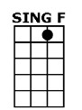
MISTER SANDMAN
4/4 in Key of F 1…2…1234 Single strums where you see an ‘!’
INTRO: Two beats per chord:
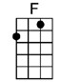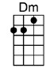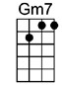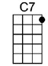
Bom Bom Bom Bom Bom Bom Bom Bom Bom Bom Bom Bom Bom

stop!
Bom Bom Bom Bom Bom Bom Bom Bom Bom Bom Bom Bom Bom ………

VERSE ONE: FOUR beats per chord
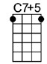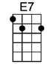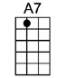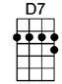

Mis….ter…Sandman, bring me a dream, make his complexion like peaches and cream

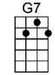

Give him two lips like roses and clover
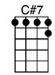

!
!
. Then tell me that my lonesome nights are over

Sandguy, I’m so alone, ain’t got nobody to call my own
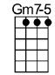

Please turn on your magic beam,

(this line just two strums each: )

Mr. Sand-man bring me a dream.

VERSE TWO: (back to four strums each: )

Mr. Sandman, YESSSSS….. bring me a dream, make him the cutest that I’ve ever seen
Give him the word that I’m not a rover

!
!
Then tell me that my lonesome nights are over

Sandguy, I’m so alone, ain’t got nobody to call my own

Please turn on your magic beam,
[[
Two strums per chord to the end ------------------------------------------------

Mr. Sand-man bring me, please, please bring me, Mr. Sand-man, bring me a dream.

Bom Bom Bom Bom Bom Bom Bom Bom Bom Bom Bom Bom Bom
stop!

Bom Bom Bom Bom Bom Bom Bom Bom Bom Bom Bom Bom Bom

KAZOO, HUM or SCAT the first page then sing this page; finishing with…

..a shimmery final line

Mr. Sandman…………….YESSSSSSSSSS!

from Dr. Uke; adapted for GBU by Harry Harrison

