All I Have To Do Is Dream by The Everly Brothers
1. Shaded = all sing; 2. ‘!’ = single strums; 3.*D7! = strum each beat; 4. **G = every half-beat
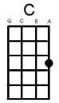
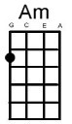
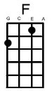
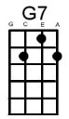
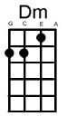
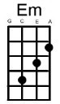
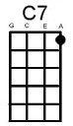
[C] Dre[Am]am [F] dream dream [G7] dream
[C] Dre[Am]am [F] dream dream [G7] dream

When [C] I want [Am] you [F] in my [G7] arms
When [C] I want [Am] you [F] and all your [G7] charms
When[C] ever I [Am] want you [F] all I have to [G7] do is
[C] Dre[Am]am [F] dream dream [G7] dream

When [C] I feel [Am] blue [F] in the [G7] night
And [C] I need [Am] you [F] to hold me [G7] tight
When[C]ever I [Am] want you
[F] All I have to [G7] do is [C] dre[F]a[C]m [C7]

[F!] I can make you mine [Em!] taste your lips of wine
[Dm!] Anytime [G7!] night or [C!] day [C7!]
[F!] Only trouble is [Em!] gee whiz
I'm *[D7!] dreaming my life a**[G]way [G7]

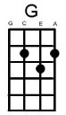
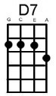
I [C] need you [Am] so [F] that I could [G7] die
I [C] love you [Am] so [F] and that is [G7] why
When[C]ever I [Am] want you [F] all I have to [G7] do is
[C] Dre[Am]am [F] dream dream [G7] dream
[C] dre[F]a[C]m [C7]

[F!] I can make you mine [Em!] taste your lips of wine
[Dm!] Anytime [G7!] night or [C!] day [C7!]
[F!] Only trouble is [Em!] gee whiz
I'm *[D7!] dreaming my life a**[G]way [G7]

I [C] need you [Am] so [F] that I could [G7] die
I [C] love you [Am] so [F] and that is [G7] why
When[C]ever I [Am] want you [F] all I have to [G7] do is

[C] Dre[Am]am [F] dream dream [G7] dream
[C] Dre[Am]am [F] dream dream [G7] dream
[C] Dre[Am]am [F] dream dream [G7] dream [C] dream

From Richard G’s Ukulele Songbook; arranged for Great Big Ukes by Harry Harrison

